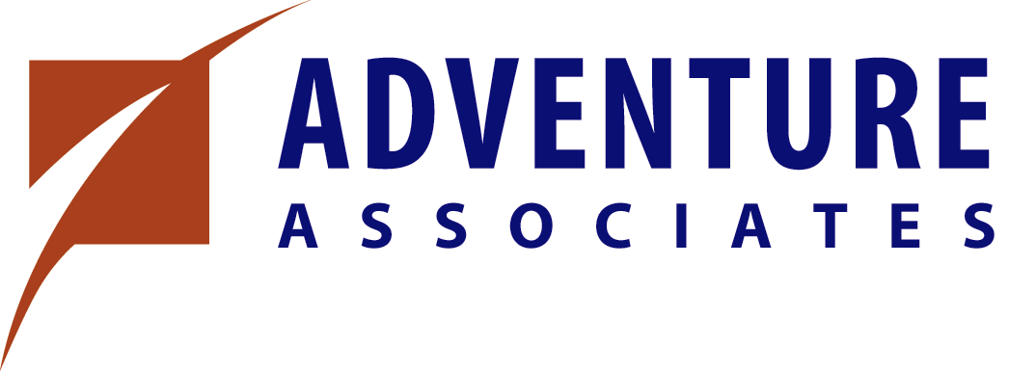

STATEMENT OF UNDERSTANDING & LEGAL RELEASE

I am aware in signing this statement for participation in the Adventure Programs offered by Adventure Associates Inc., that certain elements are physically demanding. Therefore, as a staff member, I should only participate in the Adventure Programs if I am free of medical or physical conditions, which might create undue risk to others or myself who depend on me.

I am aware that this activity involves a potential for injury to my person and property. To the extent that I participate in such activities, I do so voluntarily and assume full responsibility for any loss and/or inconvenience resulting from an injury to my person and/or property resulting therefrom. I further agree to indemnify and hold harmless, Adventure Associates Inc., and their agents from any and all liability incurred as a result of my participation.

I also agree that the terms hereof shall serve as a release and assumption of risk for my heirs, executors and administrators, and for all members of my family, including any minors.

Signature: ____________________________________ Date: __________________

Participant’s Name: ____________________________ Phone: _________________
(please print legibly)

Emergency Contacts: ___________________________ Phone: _________________

___________________________ Phone: _________________

I currently am ___ am not ___ covered by medial/health insurance.

Health Insurance Carrier: ________________________ Policy Number: __________

Please indicate any allergies you have or any medications you are taking: _______________

_______________________________________________________________________

Please list any health conditions, which may limit your full participation: _______________

_______________________________________________________________________

The information on this sheet is entirely confidential.

